Electricity

Bill Management System

BY:

|  |  |
| --- | --- |
| NAME: | ROLL NO: |
| UVAN SHANKAR S J | CB.EN.U4CSE20368 |
| M HARIHARAN | CB.EN.U4CSE20320 |
| AMRITESH P J | CB.EN.U4CSE20305 |
| SAKTHI VIKKRAMAN R | CB.EN.U4CSE20353 |

**Problem Statement:**

A electricity bill management system is a framework that allows the customers or users to pay their electricity bill through online payment method without any hassle. The system should be able to send alerts on due dates of payments, modify data of customers and update the bill amount.

**Introduction:**

The Electricity bill management system is a project that will help in the storage of details of user and admin electronically in a database system. This infrastructure will help the user and admin to easily keep track of the information. Sending out alerts to each pending payment is a hassle if done manually, the automation of this through this framework will reduce a lot of manual labour. Keeping electronic tabs will minimise errors to a large extent.

**Functionalities:**

An employee from the Electric Board will manually update the power used by a house. The user will be charged accordingly to the power consumed. Each user will be put into two different slabs, commercial and domestic respectively. The cost of each unit will depend on the slab. The user will pay a particular deposit amount for establishing the electricity connection for the first time. The user will be updated regularly on the payment date. The power connection will be removed if the user fails to meet few criteria.

**Revised Entity Relationship Diagram**

**Normalization**

**Schema before normalisation:**

* Admin(admin_id, username, admin_name, st_name, hno, ad_phone number)
* Bill (bill_no, cust_id, priceperunit, unit, due_date)
* Invoice (invoice_id, admin_id, cust_id, unit, status)
* Announcement(st_name,message,admin_name,admin_id)
* Reads(cust_id,stname)
* User(username,cust_id,H_no,st_name, phone-no,f_name,L_name,phoneno)
* Login(username, password, role, Date)
* Feedback (fb_id , cust_id, feedback , admin_id)

**1 NF:**

* Each column of the schema contains only atomic values, there are no column which contain two or more values.
* Each column has stored only values of same data type.
* Each schema in the column can be uniquely identified as no two columns in the schema has the same name.
* Therefore, the schema are already in 1NF.

**2 NF:**

**Dependencies :**

* admin_id -username, admin_name, st_name, hno, ad_phone number
* bill_no -invoice_id, cust_id, ppu_id, unit, amount
* invoice_id -admin_id, cust_id, unit, status
* st_name -message, admin_name, admin_id
* cust_id - username, H_no, st_name, phone-no, f_name, L_name, phoneno
* status -due_date
* Username-password, role, dob
* fb_id-cust_id, feedback , admin_id
* No partial dependency is found in the same table and each table has one primary key, hence the tables are already in 2NF.

**3 NF:**

* Bill table normalised to 3NF by creating a table 'Tariff'

1. Bill (bill_no, invoice_id, cust_id, ppu_id, unit, amount)
2. Tariff (ppu_id, priceperunit, range)

* Announcement table normalised to 3NF by removing 'admin_name' attribute due to its transitive dependency with 'admin_id'

1. announcement(st_name, message, admin_id)

* User table normalised to 3NF by creating a table 'cust' to remove transitive dependency:

1. user(Username, f_name, L_name,city)
2. district(city, district)
3. cust(cust-id, H_no,st_name, phoneno, username)

* Feedback table normalised by creating a table 'Adminfeed' to remove transitive dependency of 'admin_id')

1. feedback (fb_id, cust_id, feedback)
2. adminfeed (admin_id, fb_id)

      All other tables are in 3NF as they do not have any transitive dependency.

**BCNF**:

* In the 3NF relation it can be seen that no non-prime attribute derives a prime attribute and only the super key determines the relation of all other attributes. So we can conclude that they are in BCNF.

**Schema after Normalization:**

* Admin(admin_id,username, admin_name, st_name, hno, ad_phone number)
* Invoice (invoice_id, admin_id, cust_id, unit, status)
* Bill (bill_no, invoice_id, cust_id, ppu_id, unit, amount)
* Tariff (ppu_id, priceperunit, range)
* User(Username, f_name, L_name, city)
* district(city, district)
* cust(cust-id, H_no,st_name, phoneno, username)
* announcement(st_name, message, admin_id)
* Reads(cust_id,stname)
* Login(username, password, role, Date)
* feedback (fb_id, cust_id, feedback)
* adminfeed (admin_id, fb_id)

**Creation of Tables and Insertion of Values**

**Admin:**

* create table admin (admin_id varchar2(5), username varchar2(20),    admin_name varchar(20), st_name varchar(100),    hno varchar2(5),  ad_phone number(20),  constraint aid_pk primary key (admin_id));
* insert into admin values ('A1','Mily','Mily Heather','Vallalar','61/A','1234567890');
* insert into admin values ('A2','Shivani','Shivani R','Edmonton','CA23','1234567000');
* insert into admin values ('A3','Shashank','Shashank Krishna','Mogami','J3','1234567800');

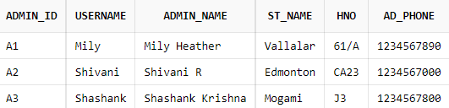

**Bill:**

* create table bill(    bill_no number(10),  invoice_id number(10),  cust_id varchar2(5),   ppu_id varchar2(5),   unit number(10),  amount number(15,2),  constraint bno_pk primary key (bill_no));
* insert into bill values ('1','1','C1','P2','450','337.50');
* insert into bill values ('2','2','C1','P3','1231','1846.50');
* insert into bill values ('3','3','C1','P1','600','300.00');
* insert into bill values ('4','4','C2','P1','512','256.00');
* insert into bill values ('5','5','C3','P1','780','390.00');
* insert into bill values ('6','6','C4','P1','749','374.50');
* insert into bill values ('7','7','C5','P3','4000','6000.00');
* insert into bill values ('8','8','C1','P4','5600','12320.00');
* alter table bill add constraint iidb_fk foreign key (invoice_id) references invoice (invoice_id);
* alter table bill add constraint cidb_fk foreign key (cust_id) references users (cust_id);
* alter table bill add constraint pidb_fk foreign key (ppu_id) references tariff (ppu_id);

**Invoice:**

* create table invoice (  invoice_id number(10),   admin_id varchar(5),  cust_id varchar2(5),  unit number(7),   status varchar(20),  constraint in_pk primary key (invoice_id));
* insert into invoice values ('1','A1','C1','450','Paid');
* insert into invoice values ('2','A2','C1','1231','Paid');
* insert into invoice values ('3','A3','C1','600','Not Paid');
* insert into invoice values ('4','A2','C2','512','Not Paid');
* insert into invoice values ('5','A2','C3','780','Paid');
* insert into invoice values ('6','A3','C4','749','Not Paid');
* insert into invoice values ('7','A1','C5','4000','Paid');
* insert into invoice values ('8','A1','C1','5600','Paid');
* alter table invoice add constraint adidi_fk foreign key (admin_id) references admin (admin_id);
* alter table invoice add constraint cuidi_fk foreign key (cust_id) references users (cust_id);

**Tariff:**

* create table tariff(ppu_id varchar2(5),   priceperunit number(5,5),  range varchar2(200),   constraint pid_pk primary key (ppu_id));
* insert into tariff values ('P1',0.5,'UNITS<500');
* insert into tariff values ('P2',0.75,'UNITS>=500 AND UNITS<1000');
* insert into tariff values ('P3',1.5,'UNITS>=1000 AND UNITS<5000');
* insert into tariff values ('P4',2.2,'UNITS>=5000');

**User:**

* create table user(username varchar(20) primary key,f_name varchar(10),L_name varchar(10),city varchar(10));
* insert into user values ('Jessica1','Jessica','Martin','chennai');
* insert into user values ('Danilol','Dani','Navi','coimbature');
* insert into user values ('Alex_tug','Alex','HK','ramanathapuram');
* insert into user values ('HrithikHRX','Hrithik','Roshan','thanjavur');
* insert into user values ('Remo_Remo','Remoni','Motwani','chennai');

**Cust:**

* create table cust(  cust_id int primary key,   H_no varchar(5),   st_name varchar(10),phone_no varchar(11), username varchar(20));
* insert into cust values ('C1','23I','EL Plazzo','9876543210','Jessica1');
* insert into cust values ('C2','4US','Lol_st','9876543200','Danilol');
* insert into cust values ('C3','45EU','Eunumera_st','9876543000','Alex_tug');
* insert into cust values ('C4','444I','remura_st','9876540000','HrithikHRX');
* insert into cust values ('C5','22US','Othello','987650000','Remo_Remo');

District:

* create table district( city varchar(20) primary key, district varchar(20));
* insert into district values ('chennai','tamilnadu');
* insert into district values ('coimbature','tamilnadu');
* insert into district values ('ramanathapuram','tamilnadu');
* insert into district values ('thanjavur','tamilnadu');
* insert into district values ('chennai','tamilnadu');

**Announcement:**

* create table announcement ( st_name varchar(20),message varchar(50),admin_id varchar(5));
* insert into announcement values ('EL Plazzo','supply cut on (9am-5pm)22-12-2021','A1');
* insert into announcement values ('Lol_st','supply cut on (2pm-3pm)09-08-2021','A2');
* insert into announcement values ('Eunumera_st','supply cut on (1am-6am)05-05-2021','A3');
* insert into announcement values ('remura_st','supply cut on (5pm-10pm)06-06-2021','A1');
* insert into announcement values ('Othello','supply cut on (10am-5pm)07-07-2021','A2');
* insert into announcement values ('Vallalar','none','A2');
* insert into announcement values ('Edmonton','supply cut on (10am-5pm)07-07-2021','A1');
* insert into announcement values ('Mogami','supply cut on (10am-5pm)07-07-2021','A3');

Login:

* create table login( username varchar2(50), password varchar2(25) NOT NULL,role varchar(10),dob Date,constraint uname_pk primary key (username));
* insert into login values ('Mily','Mily1234','admin','02-jul-1981');
* insert into login values ('Jessica1','Jessica@0','user','23-apr-1950');
* insert into login values ('Danilol','Dani-elc','user','13-jan-1956');
* insert into login values ('Shivani','s12vani','admin','14-aug-1960');
* insert into login values ('Alex_tug','aaa1999','user','23-feb-1999');
* insert into login values ('HrithikHRX','Hrx@24','user','02-sep-1997');
* insert into login values ('Remo_Remo','Remo007','user','10-mar-1988');
* insert into login values ('Shashank','shasha2020','admin','01-jan-1999');

**Feedback:**

* create table feedback(fb_id number(5), cust_id varchar2(5),feedback varchar2(500),constraint fidf_pk primary key (fb_id));
* insert into feedback values ('1','C1','i get low voltage supply in my area.pls look.')
* insert into feedback values ('3','C1','pls supply us third phase in which we will apply for extra')
* insert into feedback values ('4','C4','how much for supplying current from our solar energy')
* insert into feedback values ('2','C2','nice work out there')
* alter table feedback add constraint sidf_fk foreign key (cust_id) references users (cust_id);

**Adminfeed:**

* create table Adminfeed(admin_id varchar2(5),fb_id number(5));
* insert into Adminfeed values ('A1','1');
* insert into Adminfeed values ('A2','2');
* insert into Adminfeed values ('A3','3');
* insert into Adminfeed values ('A1','4');

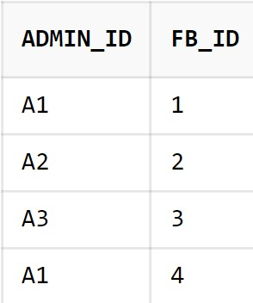

**User-Interface Design:**

**Login and Signup Page:**

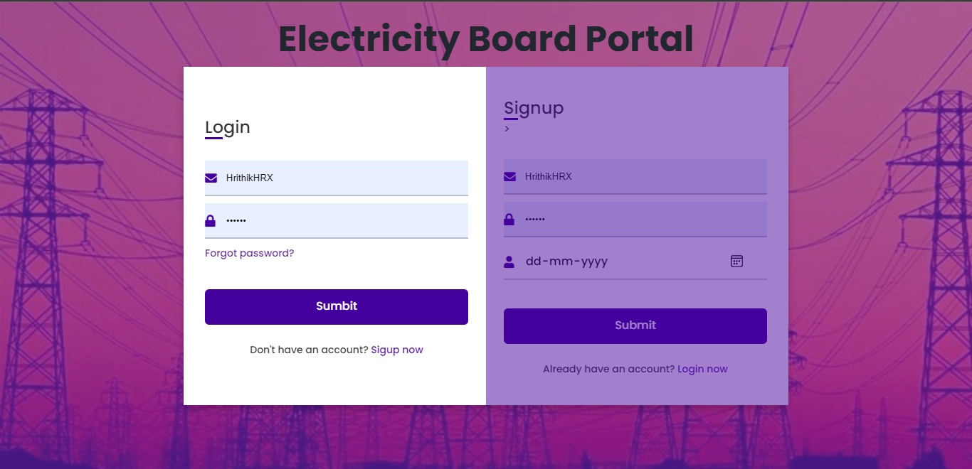

**Profile Page – User and Admin:**

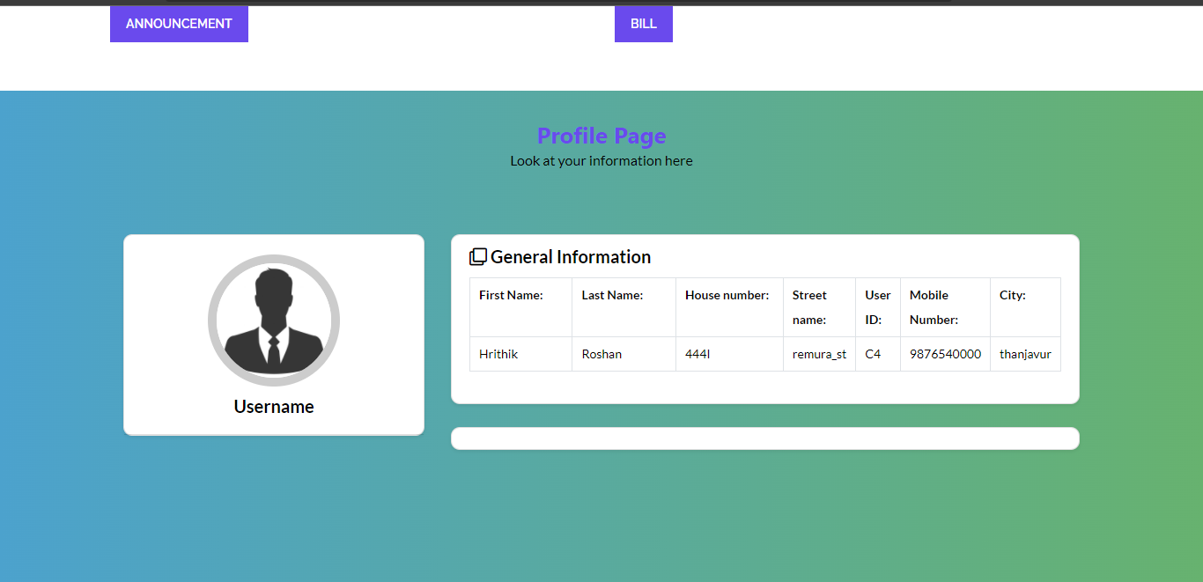

**Announcement Page:**

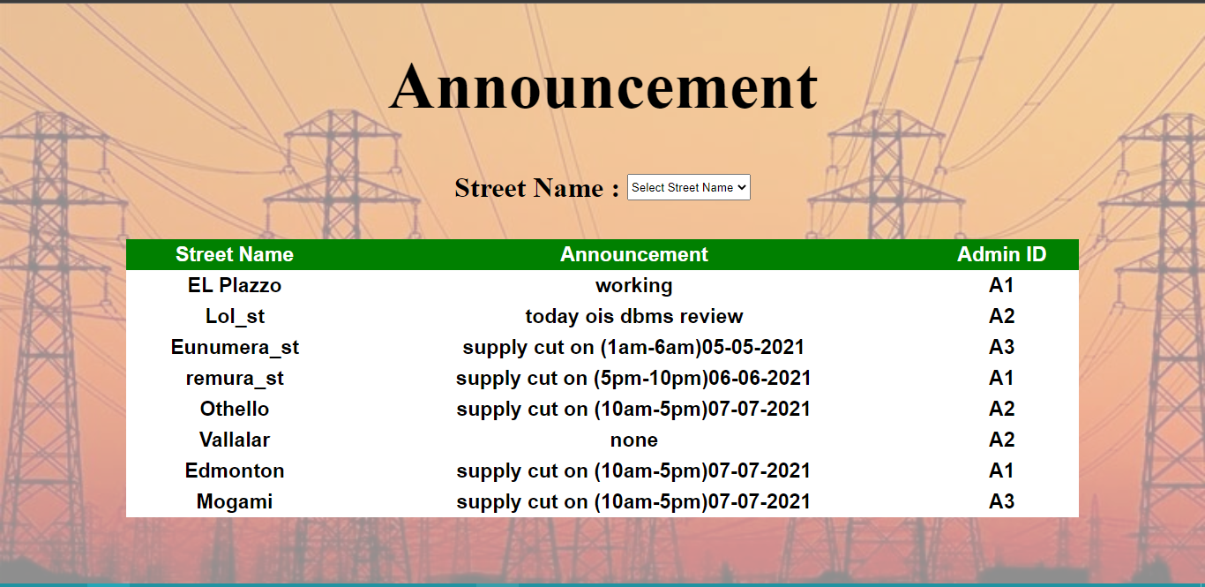

**Bill Page:**

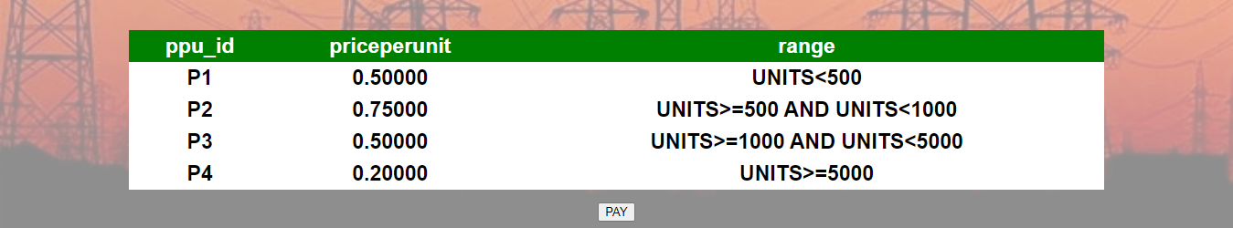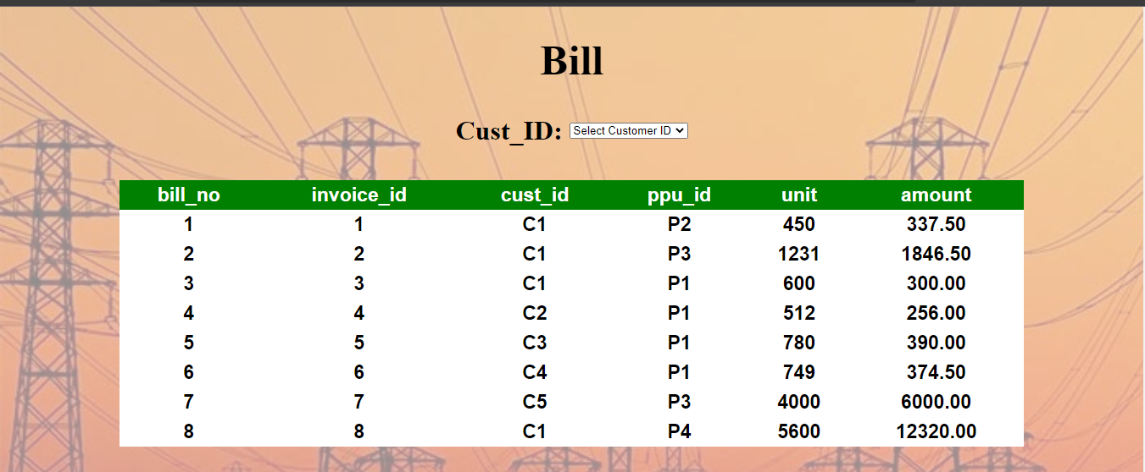

**Getting Announcement Page:**

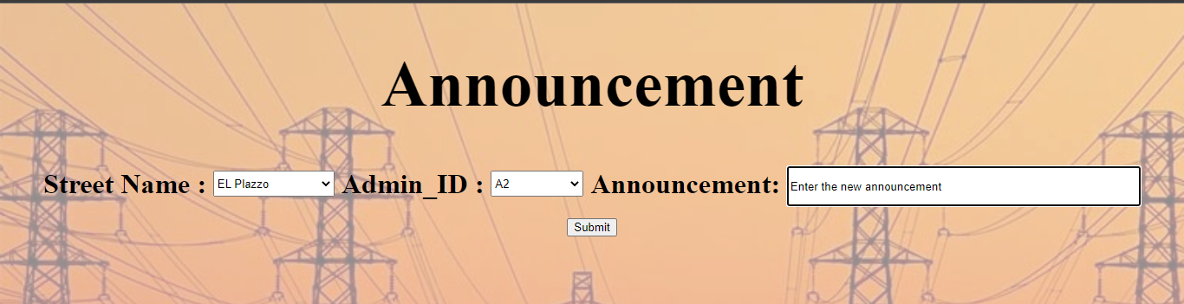

**Invoice:**

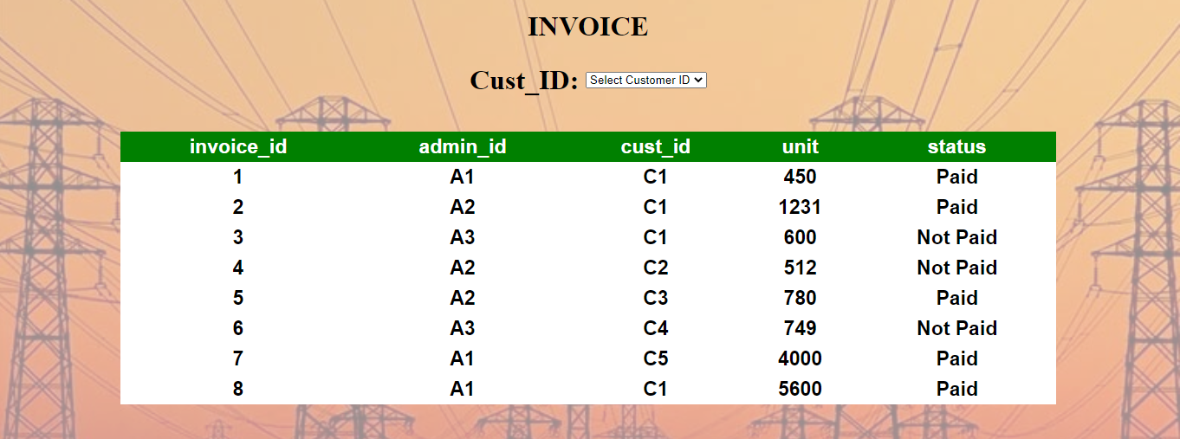

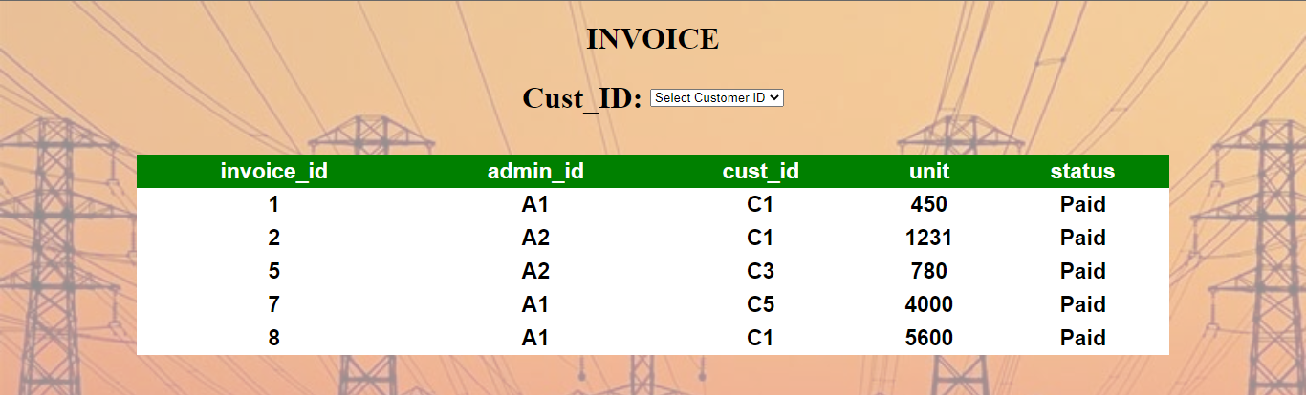**Paid bill:**

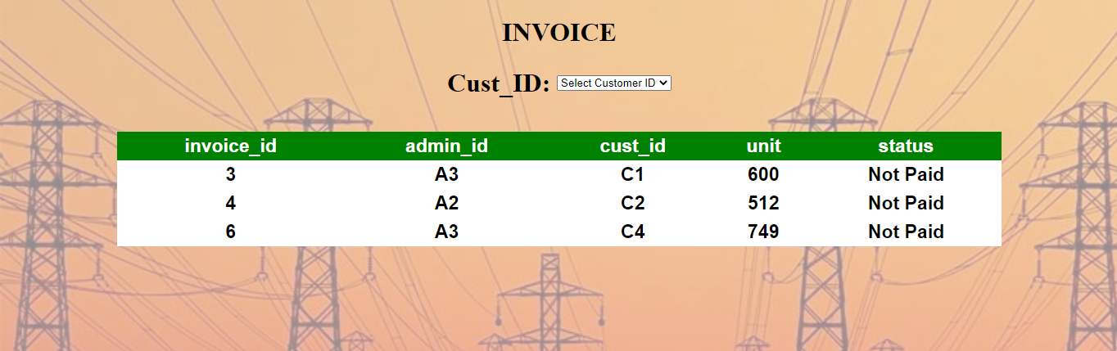**Not-Paid bill:**

**Feed Back Page:**

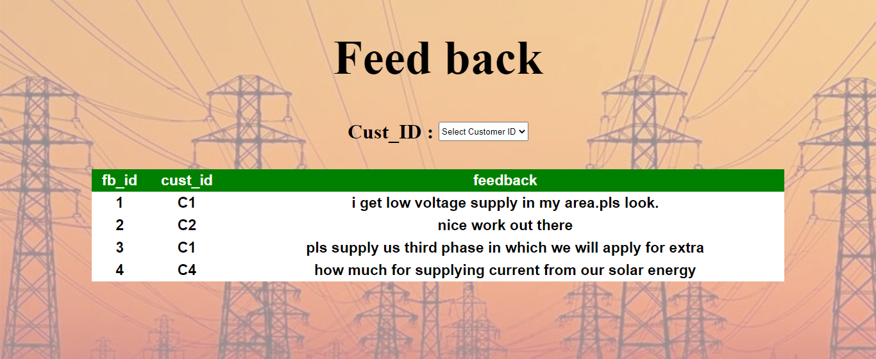

**CODE:**

**For filter the data and displaying them(** **All the values are get from the form and used in the php by GET method.)**

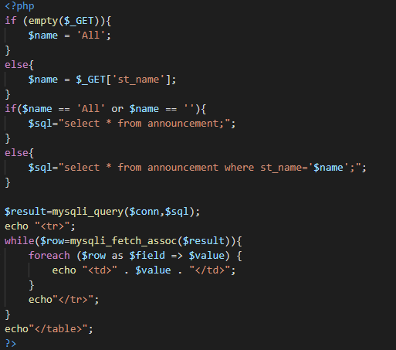

**For updating the data to the table(** **All the values are get from the form and used in the php by GET method.)**

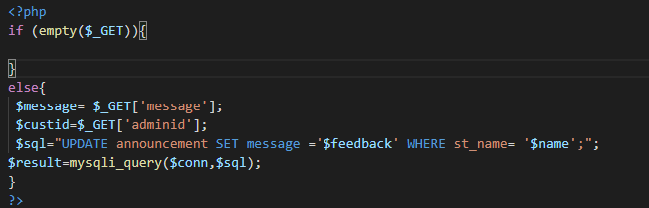

**For sending the data from one php page to other**

(**Inside the login *php*)**

**(inside the user page)**

